**Name: ____________________________**

# Differentiation and Applications

**Extended Investigation: Roller Coaster Track Design**

**Unit 3**

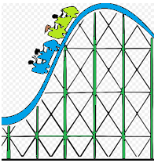**Part A (10 marks)**

The first task is to design an *ascent* and *drop* for a section of roller coaster track.

You will connect two straight stretches of track,  and , with part of a parabola , where *x* and  are measured in metres.

By studying photographs of roller coasters you decide to make the slope of the *ascent* 0.7 and the slope of the *drop*  - 1.8.

For the track to be smooth there can’t be abrupt changes in direction. To ensure smooth transitions between the linear segments and the parabola -  and  need to be tangents to the parabola *f(x)* at the transition points P and Q.

To simplify the equations, you decide to place the *origin* at *P*. Furthermore, the horizontal distance between *P* and *Q* is 16 metres.

Find the equations of the *three segments* of track indicated below for the given domains, showing all appropriate steps of logic:

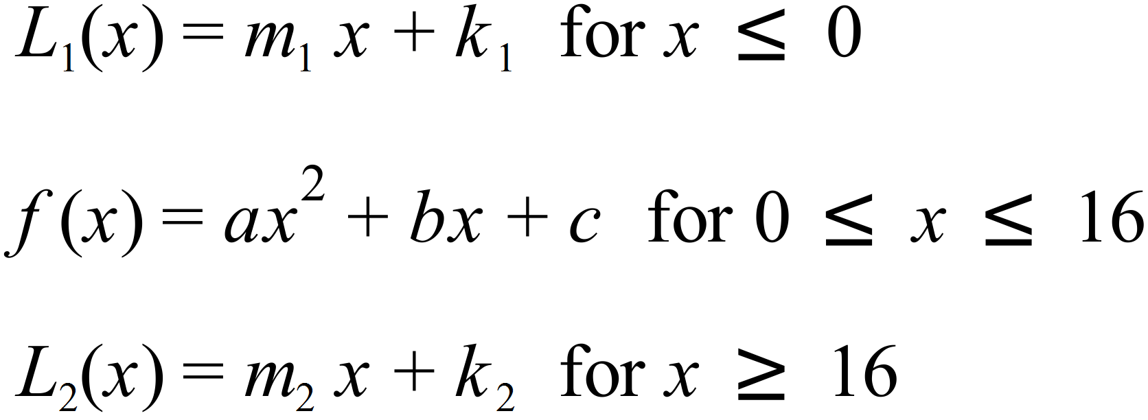

**Part B (35 marks)**

After conducting some research on roller coaster specifications, your task is to design a roller coaster and specify the equations for your roller coaster track from the ***starting point*** (entrance on the left) to its ***finish point*** (exit on the right). The three segments of track from Part A must be included in your track.

You must determine equations (minimum of 4) for the section on the left to join *L1* and equations (minimum of 3) from  *L2* to the exit point, ensuring a smooth transition between points-show detailed working, equations, constraints, reasons for the choices etc.

You must carefully consider:

-length and height constraints

-using a range of functions in your design

-consider different techniques for generating the functions

* Use graphing software, draw a detailed, fully labelled, smooth graph showing what each section looks like. You must observe the constraints of each section and need to also produce a final graph showing all sections of the roller coaster track together.
* Include a discussion of any assumptions, limitations and improvements in the design of your roller coaster.

[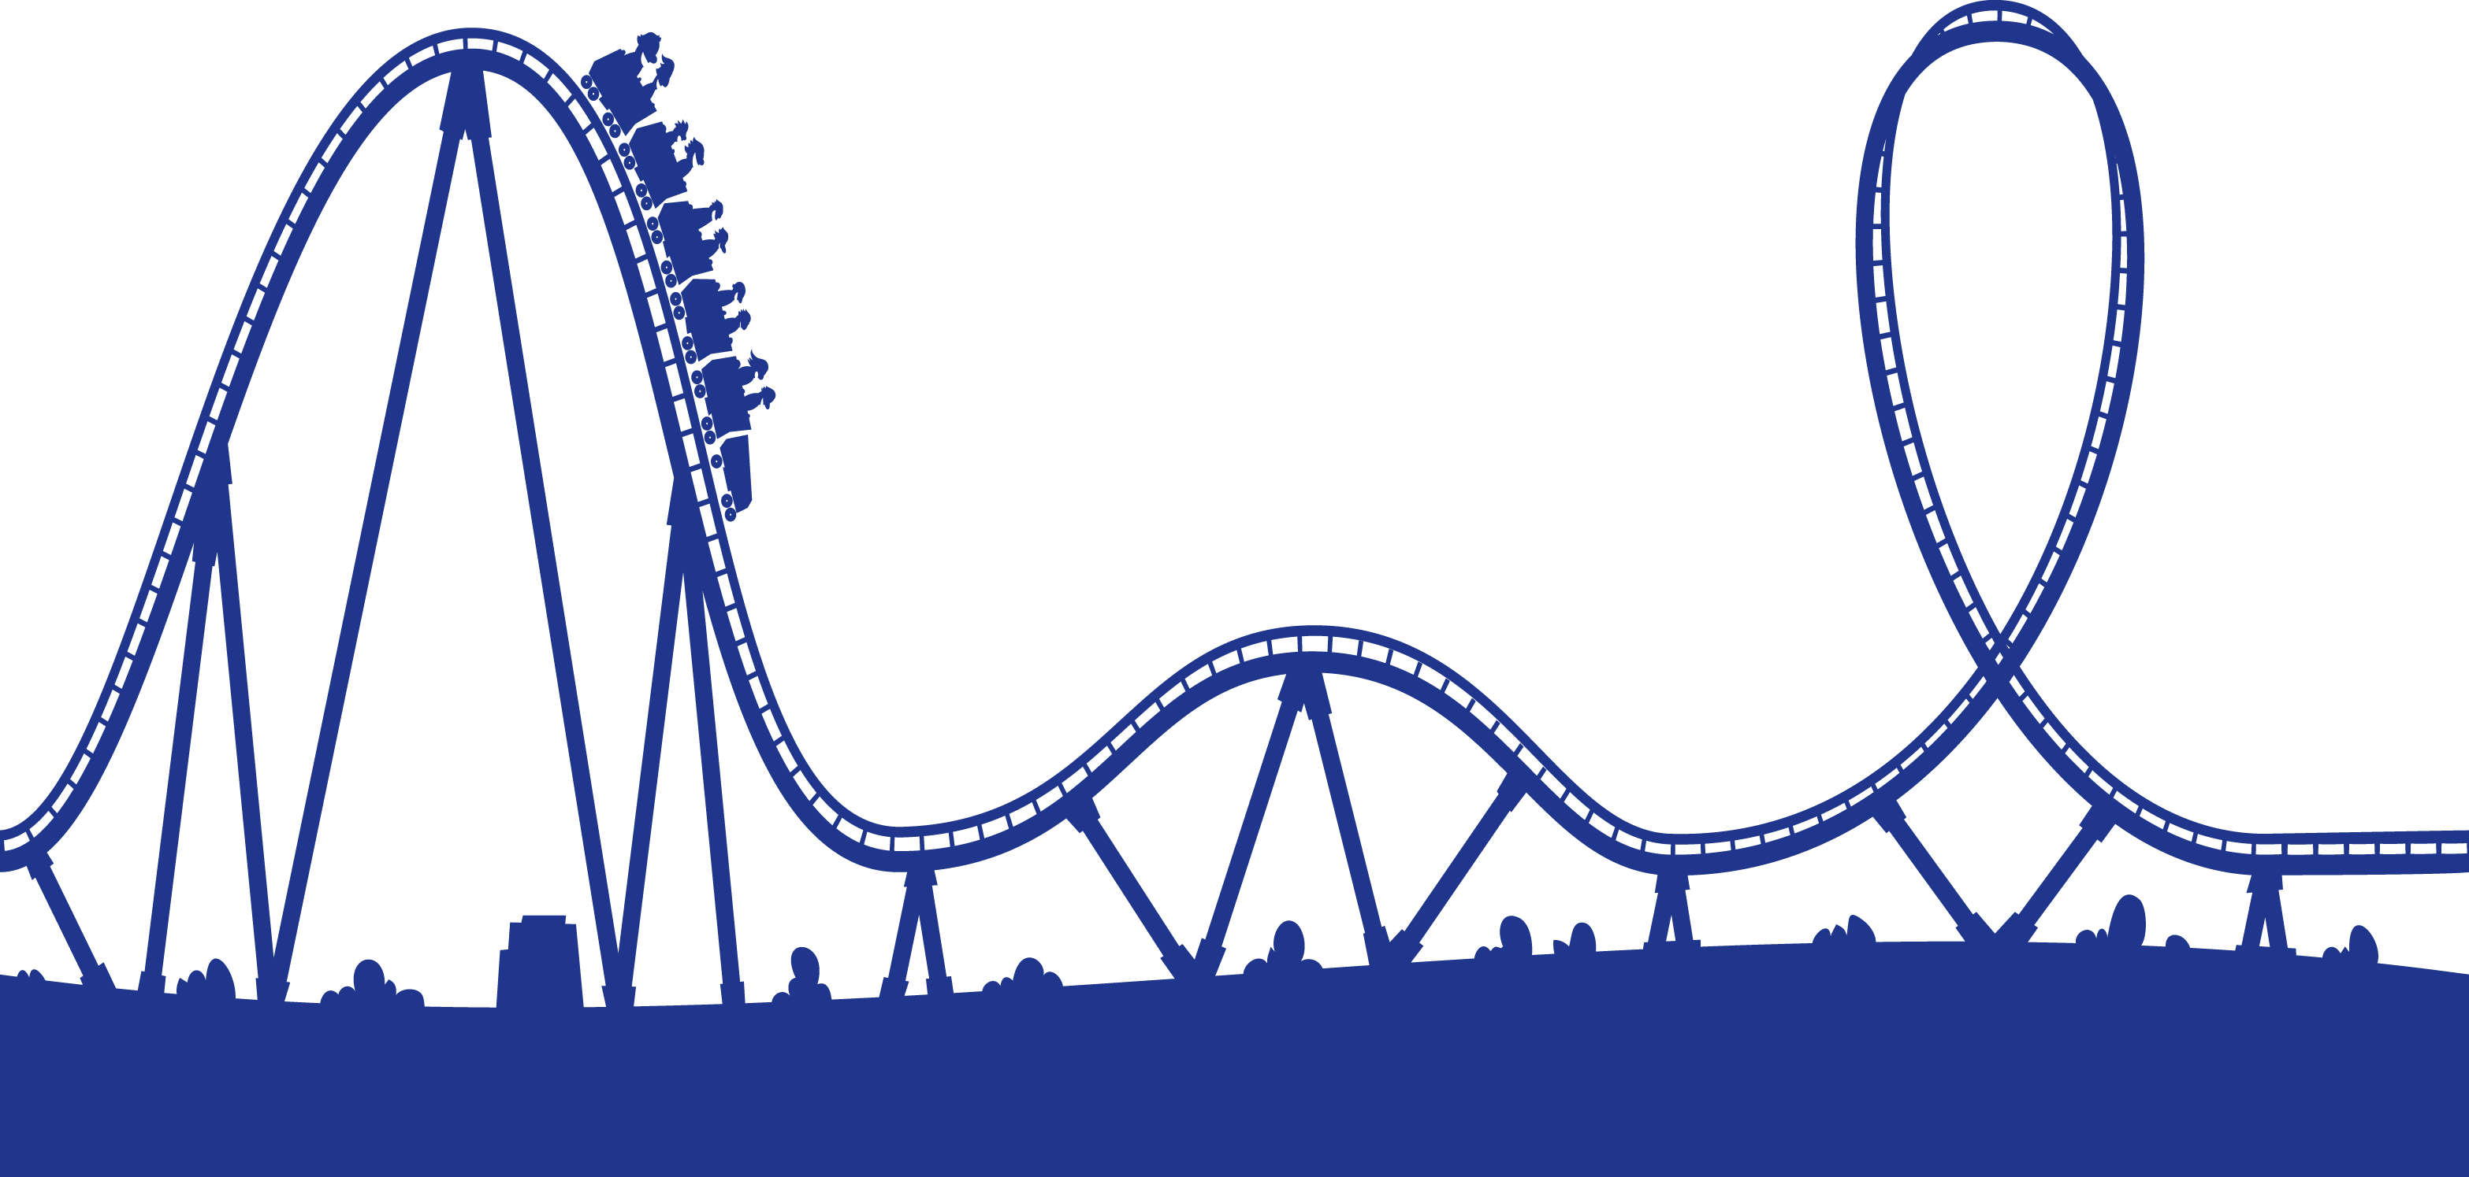](http://www.google.com.au/url?sa=i&rct=j&q=&esrc=s&source=images&cd=&cad=rja&uact=8&ved=0ahUKEwiu3K_68-XQAhWDupQKHR71DcoQjRwIBw&url=http://www.clipartkid.com/cartoon-roller-coaster-cliparts/&psig=AFQjCNGDOLcOX8vD9dBgydqxWSXPsGbdTg&ust=1481331429398684)

**The report should include the following:**

* an outline of the problem and context
* the method required to find a solution, in terms of the mathematical model or strategy used
* the application of the mathematical model or strategy, including
* relevant data and/or information
* mathematical calculations and results, using appropriate representations
* the analysis and interpretation of results, including consideration of the reasonableness and limitations of the results
* the results and conclusions in the context of the problem.

**A bibliography and appendices, as appropriate, may be used.**

The investigation report, excluding bibliography and appendices if used, must be a maximum of 15 A4 pages if written, or the equivalent. The maximum page limit is for single-sided A4 pages with minimum font size 10. Page reduction, such as 2 A4 pages reduced to fit on 1 A4 page, is not acceptable. Conclusions, interpretations and/or arguments that are required for the assessment must be presented in the report, and not in an appendix. Appendices are used only to support the report, and do not form part of the assessment decision.

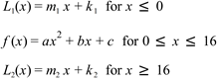 **Part A**

**1 mark for each variable and**

**1 mark for the domain**

**(Max 10 marks)**

**Part B**

Minimum of 4 equations for the section on the left to join *L1*

**2 marks for each equation and 1 mark for the domain (Max 15 marks)**

Minimum of 3 equations from *L2* to the exit point

**2 marks for each equation and 1 mark for the domain (Max 12 marks)**

**The report:**

* an outline of the problem and context (Max 2 marks)
* the method required to find a solution, in terms of the mathematical model or strategy used (Max 2 marks)
* the application of the mathematical model or strategy, including
* relevant data and/or information **(Max 2 marks)**
* mathematical calculations and results, using appropriate representations
* the analysis and interpretation of results, including consideration of the reasonableness and limitations of the results
* the results and conclusions in the context of the problem. (Max 2 marks)

**Performance Standards**

| - | Concepts and Techniques | Reasoning and Communication |
| --- | --- | --- |
| 40 – 45 marks | Comprehensive knowledge and understanding of concepts and relationships.  Highly effective selection and application of mathematical techniques and algorithms to find efficient and accurate solutions to routine and complex problems in a variety of contexts.  Successful development and application of mathematical models to find concise and accurate solutions.  Appropriate and effective use of electronic technology to find accurate solutions to routine and complex problems. | Comprehensive interpretation of mathematical results in the context of the problem.  Drawing logical conclusions from mathematical results, with a comprehensive understanding of their reasonableness and limitations.  Proficient and accurate use of appropriate mathematical notation, representations, and terminology.  Highly effective communication of mathematical ideas and reasoning to develop logical and concise arguments.  Effective development and testing of valid conjectures, with proof. |
| 30 to 39 marks | Some depth of knowledge and understanding of concepts and relationships.  Mostly effective selection and application of mathematical techniques and algorithms to find mostly accurate solutions to routine and some complex problems in a variety of contexts.  Some development and successful application of mathematical models to find mostly accurate solutions.  Mostly appropriate and effective use of electronic technology to find mostly accurate solutions to routine and some complex problems. | Mostly appropriate interpretation of mathematical results in the context of the problem.  Drawing mostly logical conclusions from mathematical results, with some depth of understanding of their reasonableness and limitations.  Mostly accurate use of appropriate mathematical notation, representations, and terminology.  Mostly effective communication of mathematical ideas and reasoning to develop mostly logical arguments.  Mostly effective development and testing of valid conjectures, with substantial attempt at proof. |
| 20 to 29 marks | Generally competent knowledge and understanding of concepts and relationships.  Generally effective selection and application of mathematical techniques and algorithms to find mostly accurate solutions to routine problems in a variety of contexts.  Successful application of mathematical models to find generally accurate solutions.  Generally appropriate and effective use of electronic technology to find mostly accurate solutions to routine problems. | Generally appropriate interpretation of mathematical results in the context of the problem.  Drawing some logical conclusions from mathematical results, with some understanding of their reasonableness and limitations.  Generally appropriate use of mathematical notation, representations, and terminology, with reasonable accuracy.  Generally effective communication of mathematical ideas and reasoning to develop some logical arguments.  Development and testing of generally valid conjectures, with some attempt at proof. |
| 10 to 19 marks | Basic knowledge and some understanding of concepts and relationships.  Some selection and application of mathematical techniques and algorithms to find some accurate solutions to routine problems in some contexts.  Some application of mathematical models to find some accurate or partially accurate solutions.  Some appropriate use of electronic technology to find some accurate solutions to routine problems. | Some interpretation of mathematical results.  Drawing some conclusions from mathematical results, with some awareness of their reasonableness or limitations.  Some appropriate use of mathematical notation, representations, and terminology, with some accuracy.  Some communication of mathematical ideas, with attempted reasoning and/or arguments.  Attempted development or testing of a reasonable conjecture. |
| Below 10 marks | Limited knowledge or understanding of concepts and relationships.  Attempted selection and limited application of mathematical techniques or algorithms, with limited accuracy in solving routine problems.  Attempted application of mathematical models, with limited accuracy.  Attempted use of electronic technology, with limited accuracy in solving routine problems. | Limited interpretation of mathematical results.  Limited understanding of the meaning of mathematical results, their reasonableness or limitations.  Limited use of appropriate mathematical notation, representations, or terminology, with limited accuracy.  Attempted communication of mathematical ideas, with limited reasoning.  Limited attempt to develop or test a conjecture. |